
Chinese English Home Page News Product Feedback About US WebMap
110V to 220V Auto Transformer
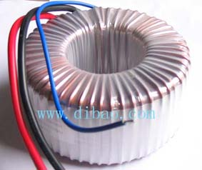
Auto 110V to 220V, 50 Hz
Item | Power Range | Dimensions |  |  |  | Weight
Item | VA | D |  | H |  | Kg | Lbs
Item | VA | mm | Inches | mm | Inches | Kg | Lbs
1 | 50 | 74 | 2.91 | 31 | 1.2 | 0.54 | 1.17
2 | 100 | 94 | 3.7 | 24 | 0.94 | 0.7 | 1.52
3 | 300 | 99 | 3.90 | 55 | 2.17 | 1.7 | 3.69
4 | 500 | 138 | 5.43 | 53 | 2.09 | 3.3 | 7.17
5 | 1000 | 138 | 5.43 | 65 | 2.56 | 4.45 | 9.66
6 | 5000 | 240 | 9.45 | 93 | 3.66 | 17.55 | 38.11

More Information About 110V to 220V Auto Transformer
Detailed Product Description

Product Directory
Power Transformer
Audio Transformer
Three Phase Transformer
Auto Transformer
Control Transformer
Power Adapter
Special Transformer

