
Chinese English Home Page News Product Feedback About US WebMap
25W Output Transformer

More Information About 25W Output Transformer
Detailed Product Description

Product Directory
Power Transformer
Audio Transformer
Three Phase Transformer
Auto Transformer
Control Transformer
Power Adapter
Special Transformer
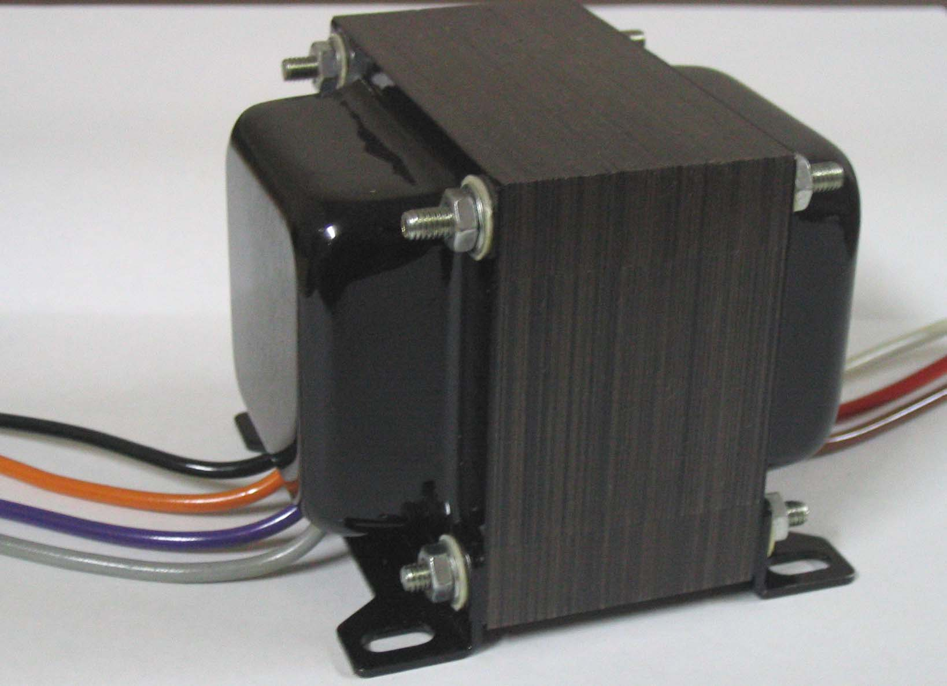
Dibao Output Transformer intended to be used in high-fidelity vacuum-tube audio amplifier. It has a low primary impedance and a high primary current capability, making it suitable for use with low-impedance triodes or pentodes. Its relatively high power and current acpability is complemented by outstanding frequency response characteristics.
We have many excellent staff and have advanced produce facilities, and manage on the basis of the request of ISO9002 strictly from design, manufacture to QC.
Guarantee products quality, welcome to contact us!

