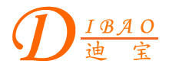
Chinese English Home Page News Product Feedback About US WebMap
HiEnd’s Power Transformer

More Information About HiEnd’s Power Transformer
Detailed Product Description

Product Directory
Power Transformer
Audio Transformer
Three Phase Transformer
Auto Transformer
Control Transformer
Power Adapter
Special Transformer
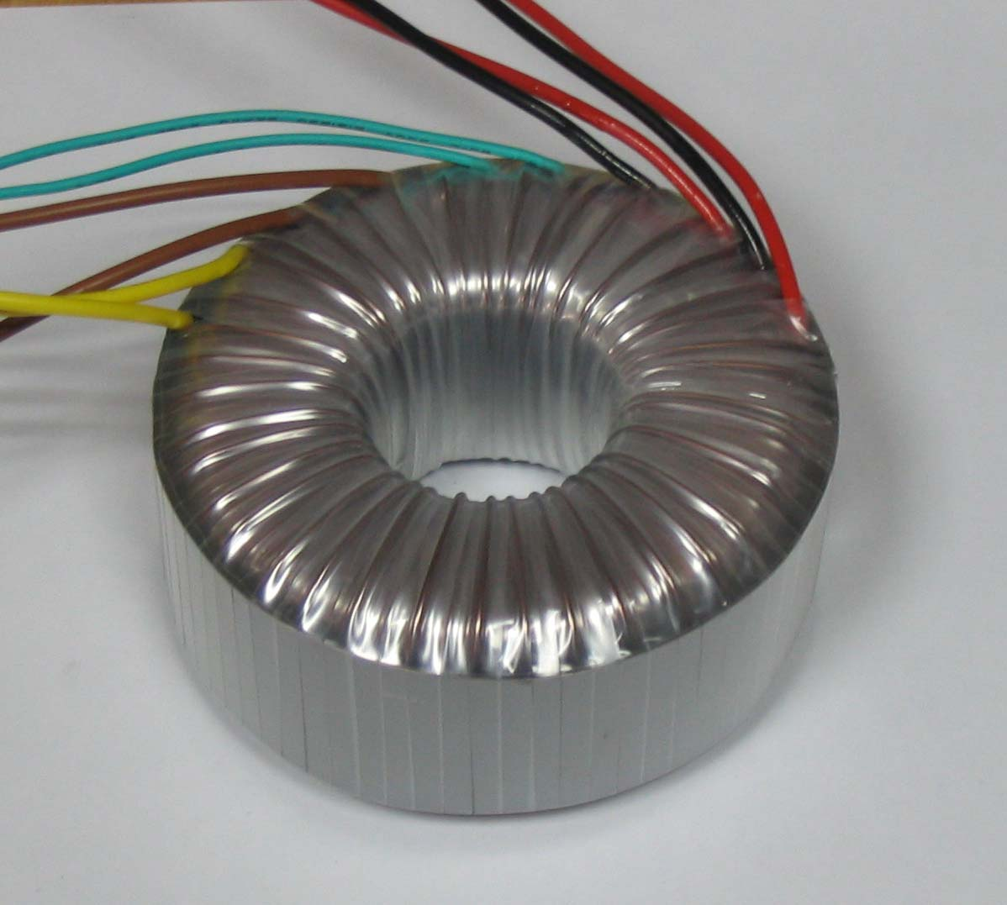
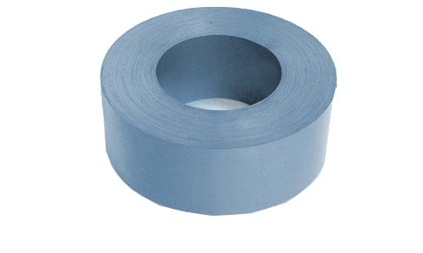
HiEnd’s Power Transformer
Today toroidal power transformer is nearly used in all of the HiEnd Audio equipments. The higher quality power transformer is for the better HiEnd. Dibao Toroidal Power Transformer is one of the best power transformers for the HiEnd.
For the best quality of the transformer we use the best materials.
The cores are wound by automatic core winding machine with a continuous silicon steel strip and are annealed in high vacuum furnace under protection atmosphere or in continuous tunnel furnace. The impregnation is done in vacuum impregnating equipment. The advanced manufacturing process makes full use of grain orientation of silicon steels, so that the core enjoys advantages such as compact volume, light, low magnetic leakage and humming, high efficiency, stable quality etc.

