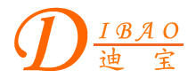
Chinese English Home Page News Product Feedback About US WebMap
Toroidal Power Transformer for Audio Device

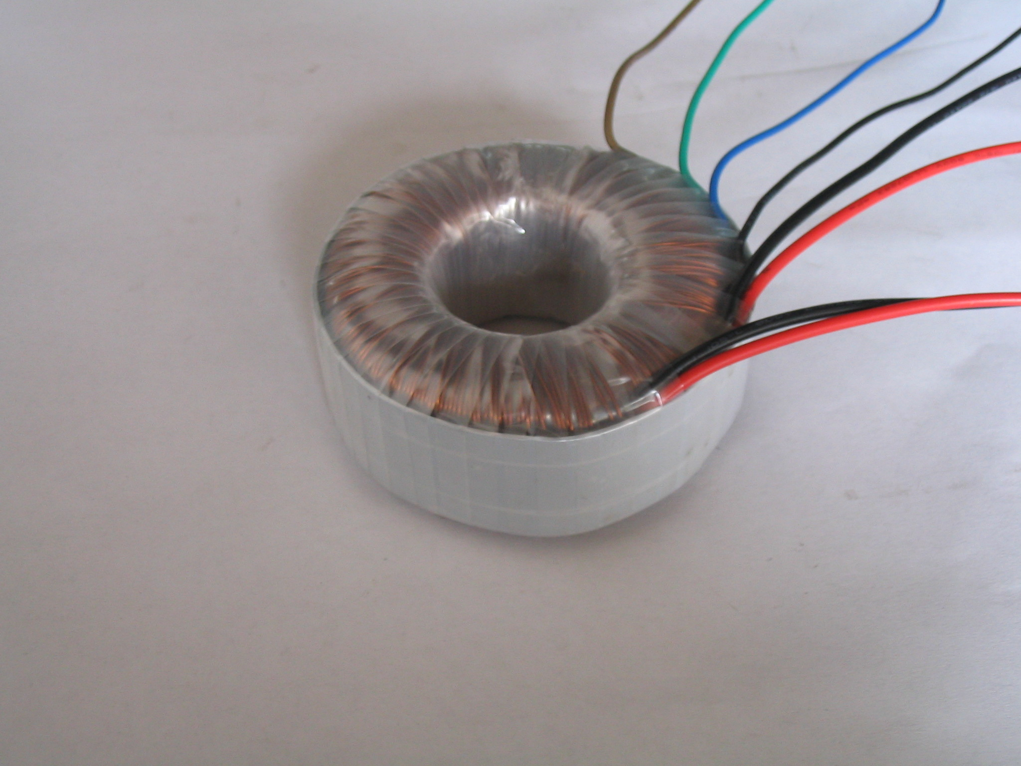

More Information About Toroidal Power Transformer for Audio Device
Detailed Product Description

Toroidal Power Transformer for Audio Device
Dibao Audio Device Toroidal Power Transformer contains many advantages such as small cubage, few flux-leakage, high efficiency, few internal-resistance and quick reaction. It is the best choice for the audio-amplifier, which needs the fearfully high capability-request
We have many excellent staff and have advanced produce facilities, and manage on the basis of the request of ISO9002 strictly from design, manufacture to QC.
Guarantee products quality, welcome to contact us!
Product Directory
Power Transformer
Audio Transformer
Three Phase Transformer
Auto Transformer
Control Transformer
Power Adapter
Special Transformer

