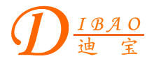
Chinese English Home Page News Product Feedback About US WebMap
Product Directory
Power Transformer
Audio Transformer
Three Phase Transformer
Auto Transformer
Control Transformer
Power Adapter
Special Transformer

Auto Toroidal Power Transformer

More Information About Auto Toroidal Power Transformer
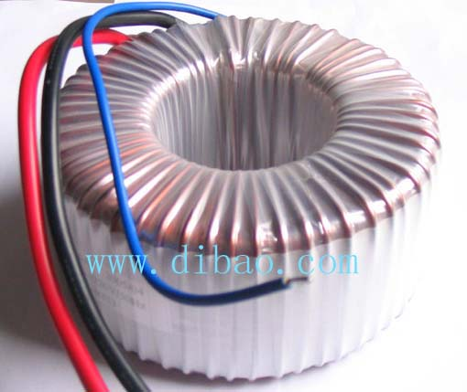
Detailed Product Description

Auto Toroidal Power Transformer
Dibao Auto Toroidal Power Transformer, from 30VA to 1000KVA power. And the output current could match with more than 3000A. Because of special configuration, It has unique feature: Low cubage, lightweight, high efficiency, low leakage, low quantity of heat, low excitation current.
We have many excellent staff and have advanced produce facilities, and manage on the basis of the request of ISO9002 strictly from design, manufacture to QC.
Guarantee products quality, welcome to contact us!

