
Chinese English Home Page News Product Feedback About US WebMap
Product Directory
Power Transformer
Audio Transformer
Three Phase Transformer
Auto Transformer
Control Transformer
Power Adapter
Special Transformer

10W Output Transformer

More Information About 10W Output Transformer

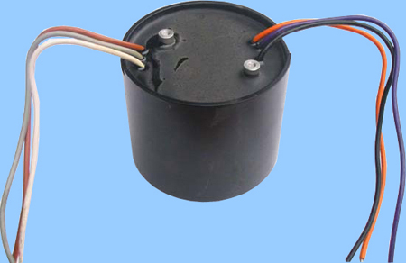
10W Output Transformer
Dibao Output Transformer intended to be used in high-fidelity vacuum-tube audio amplifier. It has a low primary impedance and a high primary current capability, making it suitable for use with low-impedance triodes or pentodes. Its relatively high power and current acpability is complemented by outstanding frequency response characteristics.
We have many excellent staff and have advanced produce facilities, and manage on the basis of the request of ISO9002 strictly from design, manufacture to QC.
Guarantee products quality, welcome to contact us!
Detailed Product Description

