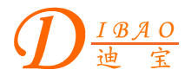
Chinese English Home Page News Product Feedback About US WebMap

More Information About C-Core Power Transformer Used For Elevator Control
Detailed Product Description

C-Core Power Transformer Used For Elevator Control
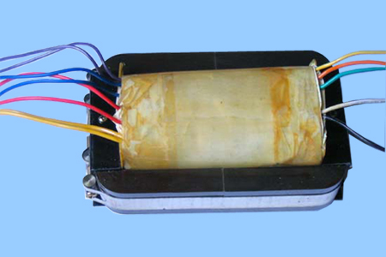
Product Directory
Power Transformer
Audio Transformer
Three Phase Transformer
Auto Transformer
Control Transformer
Power Adapter
Special Transformer

