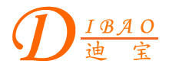
Chinese English Home Page News Product Feedback About US WebMap
Product Directory
Power Transformer
Audio Transformer
Three Phase Transformer
Auto Transformer
Control Transformer
Power Adapter
Special Transformer

More Information About 200VA Toroidal Control Transformer
Detailed Product Description

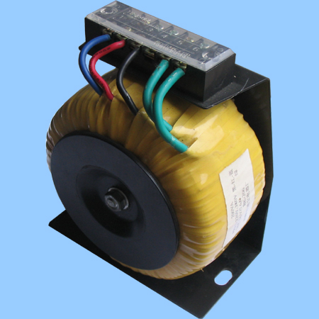
200VA Toroidal Control Transformer
Dibao control transformer applies to circuit of 50-60Hz, being used as power supply controlling, partial illumination and indication of normal electric appliances in machine tools and mechanical equipments.

I/P:0---220V---380V
O/P:36V

