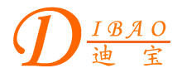
Chinese English Home Page News Product Feedback About US WebMap
Product Directory
Power Transformer
Audio Transformer
Three Phase Transformer
Auto Transformer
Control Transformer
Power Adapter
Special Transformer

More Information About C-Core Audio Transformer

C-Core Audio Transformer
Detailed Product Description

