
Chinese English Home Page News Product Feedback About US WebMap
Product Directory
Power Transformer
Audio Transformer
Three Phase Transformer
Auto Transformer
Control Transformer
Power Adapter
Special Transformer
More Information About The Toroidal Power Transformer For Audio Device
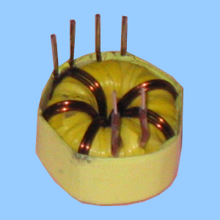
Toroidal Power Transformer For Audio Device
Input:25V
Output:220V
Frequency:40KHZ

Detailed Product Description

