
Chinese English Home Page News Product Feedback About US WebMap
Product Directory
Power Transformer
Audio Transformer
Three Phase Transformer
Auto Transformer
Control Transformer
Power Adapter
Special Transformer

More Information About R-Core Transformer
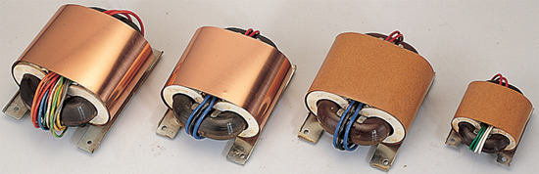

R-Core Transformer Features:
*Without fracture;
*With round section area;
*Horizontal, thinness, adapt to high density' installation;
Compare to E&I transformer:
a. 30% smaller and 40% lighter;
b .Low magnetic loss upward of 90%;
c .Temperature raise lower under 50%;
d .Winding is round, medial winding length reduce 6% ~10%,low cuprum loss.

Sizes Of Form And Installation:
Model | Capacity  (VA) | Size Of Product(mm) |  |  | Installation Size(mm) |  |  |  | Weight  kg
Model | Capacity  (VA) | A | W | X | E | F | G | T | Weight  kg
PR-10 | 15 | 74 | 61 | 37 | 68.4 | 48 | 4×5 | 1.0 | 0.4
PR-20 | 25 | 81 | 70 | 39 | 55 | 50 | M3 | 1.0 | 0.5
PR-30 | 40 | 96 | 77 | 42 | 70 | 60 | Φ5 | 1.0 | 0.7
PR-40 | 50 | 98 | 80 | 44 | 70 | 60 | Φ5 | 1.0 | 0.9
PR-50 | 60 | 101 | 92 | 48 | 75 | 65 | Φ5 | 1.0 | 1.0
PR-80 | 100 | 124 | 90 | 52 | 90 | 70 | Φ5 | 1.2 | 1.4
PR-100 | 120 | 124 | 103 | 55 | 100 | 80 | Φ5 | 1.2 | 1.7
PR-160 | 180 | 138 | 115 | 63 | 100 | 85 | Φ5 | 1.6 | 2.6
PR-260 | 280 | 156 | 121 | 66 | 130 | 95 | Φ5 | 1.6 | 3.1
PR-320 | 380 | 163 | 128 | 70 | 135 | 95 | Φ5 | 1.6 | 3.8
PR-600 | 600 | 182 | 145 | 85 | 142 | 100 | Φ8 | 1.6 | 6.5
PR-1000 | 1000 | 222 | 172 | 99 | 180 | 140 | Φ8 | 2.6 | 10.5

The Picture About R-Core Transformer’s Size And Installatiaon
Detailed Product Description

