Dibao small toroidal transformer

Dibao small toroidal transformer is the special toroidal transformer, which we newly design and manufacture. Now the small toroidal transformer means that the output rated wattage is 4VA to 25VA. The advanced manufacturing process makes full use of our special technic so that the transformer enjoys advantages such as compact volume, light, low magnetic leakage and humming, high efficiency, stable quality etc. And the capability of the product matches with the request of Stander GB13028-91. It is good to use for different kinds of audio and video products.
The cores of toroidal transformers are wound by automatic core winding machine with a continuous silicon steel strip and are annealed in high vacuum furnace under protection atmosphere or in continuous tunnel furnace. The impregnation is done in vacuum impregnating equipment. The advanced manufacturing process makes full use of grain orientation of silicon steels. There is 25％ lower magnetic leakage and core wastage comparing with the EI core so that it brings below advantages:
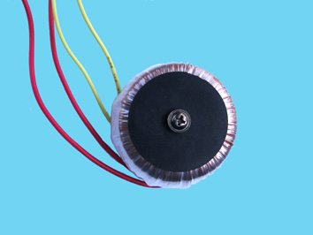
1) The small toroidal transformer has high electrical efficiency. The magnetic induction strength reaches 1.5---1.8T
2) The small toroidal transformer has compact volume and light, simple operation and big designing space.
3) The small toroidal transformer has low magnetism leakage.
4) The small toroidal transformer has low noise, low shocking.
5) The small toroidal transformer has low consuming low temperature rising.
6) It is easy to be setting.

ADD: NO.18 Qingyun Industrial Park Diebei District Guicheng Town Nanhai Area Foshan City China
Website:http://www.dibao.com E-mail: dibao@dibao.com
TEL: 86-757-86308642 FAX: 86-757-86318580

