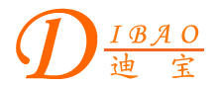
Chinese English Home Page News Product Feedback About US WebMap
Product Directory
Power Transformer
Audio Transformer
Three Phase Transformer
Auto Transformer
Control Transformer
Power Adapter
Special Transformer

More Information About Vertical R-core Transformer For Professional Audio Device
Vertical R-core Transformer For Professional Audio Device
*Without fracture;
*With round section area;
*Horizontal, thinness, adapt to high density' installation;
Compare to E&I transformer:
a. 30% smaller and 40% lighter;
b .Low magnetic loss upward of 90%;
c .Temperature raise lower under 50%;
d .Winding is round, medial winding length reduce 6% ~10%,low cuprum loss.

Detailed Product Description
