
Chinese English Home Page News Product Feedback About US WebMap
Dual C-Core Output Transformer

More Information About Dual C-Core Output Transformer
Detailed Product Description

Product Directory
Power Transformer
Audio Transformer
Three Phase Transformer
Auto Transformer
Control Transformer
Power Adapter
Special Transformer
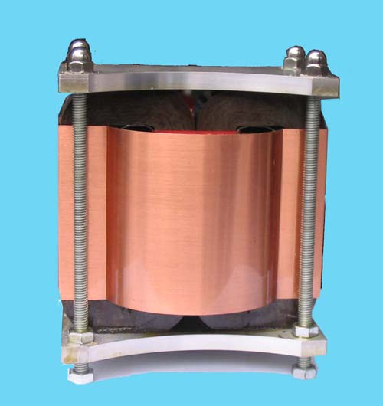
Dual C-Core Output Transformer
A high-quality output transformer is the heart of the tube amplifier. A poor output transformer fitted in a well-designed amplifier will spoil its performance.
Needless to say that the design and optimization of an output transformer takes high skill and know-how because performance requirements are complex and high. The transformer must deliver adequate and constant power without core saturation. It should provide wide frequency bandwidth at a minimum distortion. Moreover, it should provide a constant outstanding performance to retain the open, spacious qualities of recorded music.
The sound quality of Dibao Dual C-Core Output Transformer is exceptional: low distortion and an extremely wide frequency and dynamic range. It has a double C core and has been carefully wound, has no internal solder joints, is impregnated and encapsulated in metal housing. There are four threaded mounting bolts for easy installation.

