120VA potted power transformer
P/N: | A1461544
Power: | 120VA
Rated input: | 115V, 115V/50Hz
Rated output: | (no load)220V-0-220V, 15.5V, 8.7V
Insulation resistance: | ≥500MΩ
Insulation strength: | Primary-Secondary: 4000V/2mA/2 S  Secondary-pot: 2500V/2mA/2S
Insulation ranking: | Class B
Temperature rise: | ≤65℃
Lead wire: | ①②③④: 300mm  ⑤⑥⑦⑧⑨⑩⑪: 300mm
⑧

⑨
0V
15.5V
⑥

⑦

0V
220V
⑤

220V
⑩
⑪
0V
8.7V
Schematic
①
②
0V
115V

③
④
0V
115V

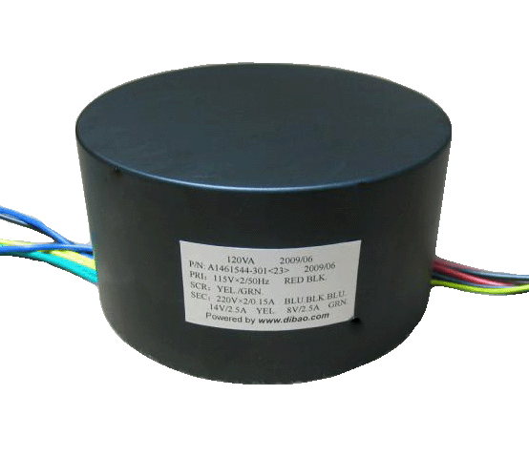

Potted power transformer
www.dibao.com
Dimension  (mm) | D | 125
Dimension  (mm) | H | 66
Mounting  (mm) | Center screw  M8
Weight
(Kg)
Potted power transformer
Transformer enclosed in 2mm thickness steel pot
H
D
Center screw
2mm

www.dibao.com
www.dibao.com

