41VA potted power transformer
P/N: | A1461543
Power: | 41VA
Rated input: | 115V, 115V/50Hz
Rated output: | (no load)16V-0-16V, 9V
Insulation resistance: | ≥500MΩ
Insulation strength: | Primary-Secondary: 4000V/2mA/2 S  Secondary-pot: 2500V/2mA/2S
Insulation ranking: | Class B
Temperature rise: | ≤65℃
Lead wire: | ①②③④: 300mm  ⑤⑥⑦⑧⑨: 300mm

Schematic
⑥

⑦

0V
16V
⑤

16V
①
②
0V
115V
③
④
0V
115V

⑧

⑨
0V
9V

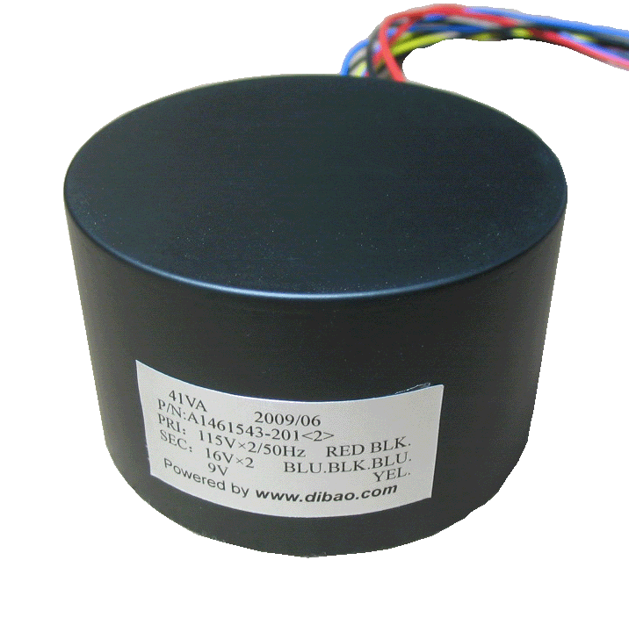

www.dibao.com
Potted power transformer
Dimension  (mm) | D | 87
Dimension  (mm) | H | 53
Mounting  (mm) | Center screw  M5
Weight
(Kg)
Potted power transformer
Transformer enclosed in 2mm thickness steel pot
D
Center screw
2mm

H
www.dibao.com
www.dibao.com

